**Name: Syeda Zainab**

**Roll no: 24 MS DS020**

**Sub: Data Science Tool & Techniques**

**Assignment NO:01**

**Submitted to: Ma’am Dr.Sanam Narejo**

**Exercise**

1. Make a dataset of student scores then calculate the total score for each student using the SUM function.

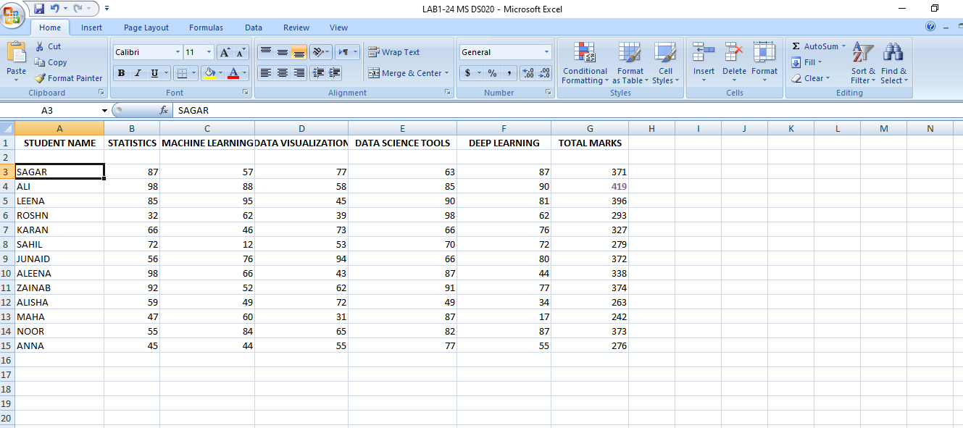

1. Calculate the average marks for a set of students using the AVERAGE function.

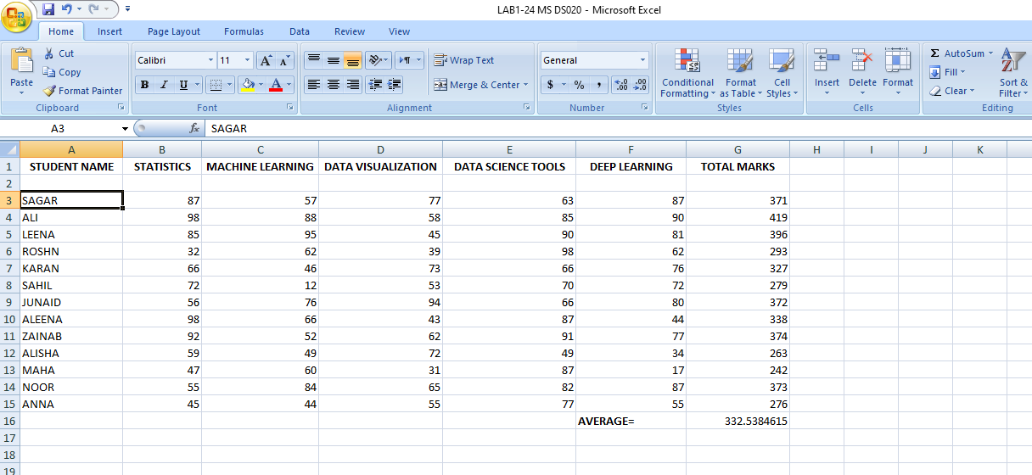

1. Sort a list of names alphabetically using the sorting feature in Excel.

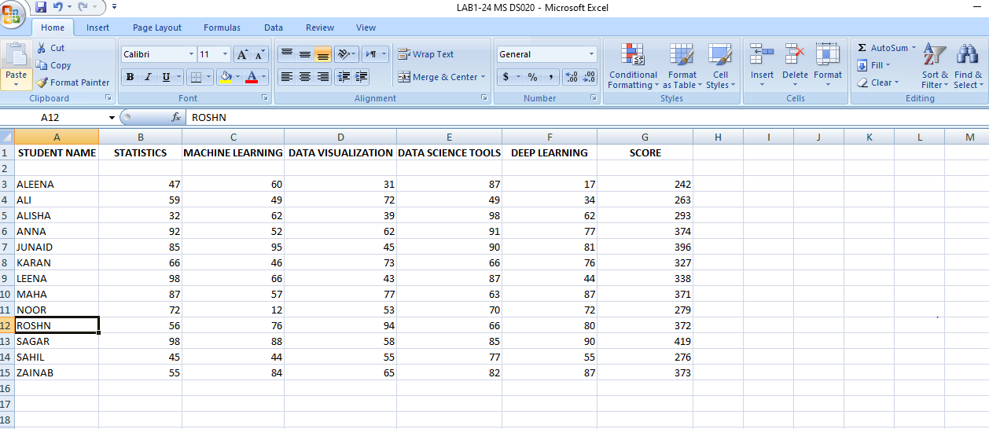

1. Calculate the average marks for a set of students using the AVERAGE function



.

1. Apply formatting (bold, italics, colors) to highlight the top-performing student in the dataset.

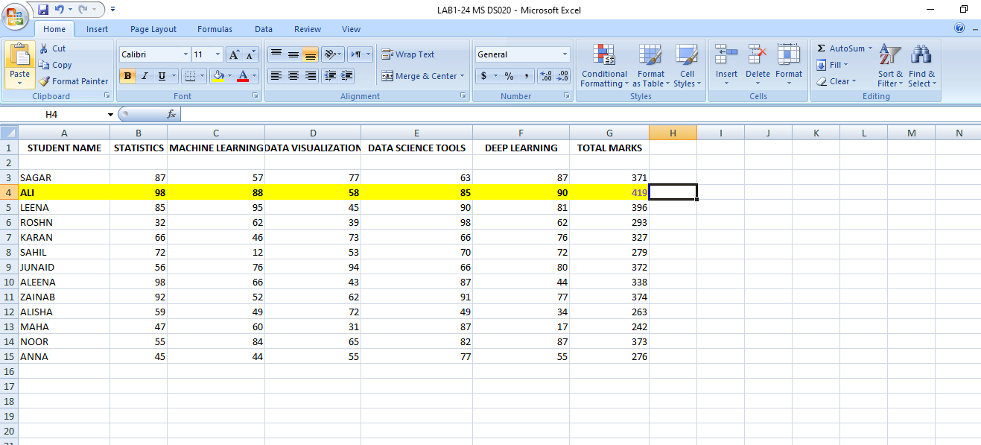

1. Create a basic Pivot Table to summarize the sales data of different products.

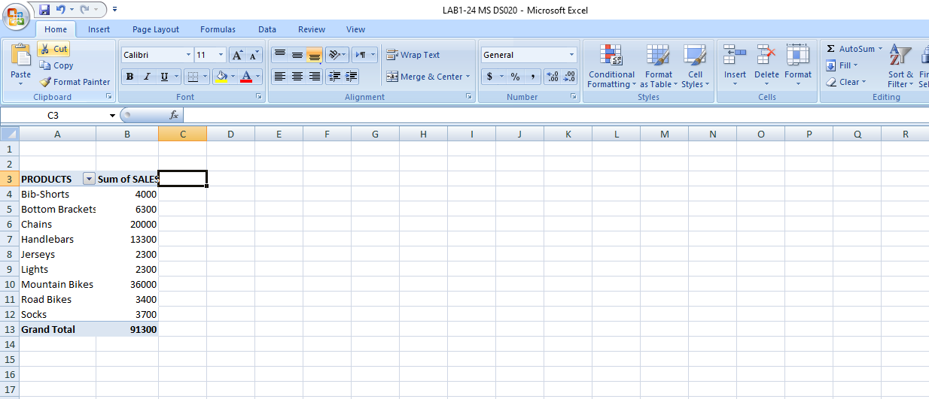

1. Generate a Pivot Chart from the previously created Pivot Table to visualize product sales trends.

